History Paper
Student’s Name
Institution
Date

History Paper
Question 1 (1 point)

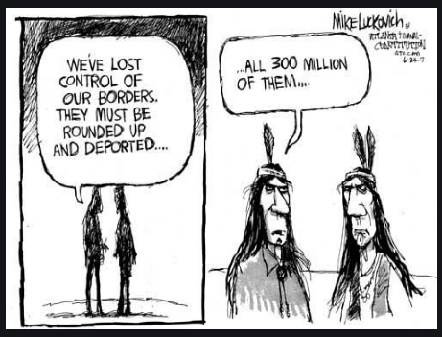
The main message of the cartoon is
Question 1 options:
 | Indigenous People originally controlled and owned the land
 | The borders of reserves must be moved
 | The RCMP is not doing an adequate job of policing the borders
 | Indigenous People are working towards increasing territorial lands
Question 2 (1 point)

In traditional Indigenous governance, decisions were made through discussion and consensus rather than by voting. Why did groups take the time to make decisions in this manner? Provide at least two reasons.
Traditional groups took time to make decisions using consensus and discussion—the processes allowed in making high-quality decisions through a robust support system. People made decisions by creating plans that addressed issues. The traditional people valued discussion and consensus in ensuring better decisions get made in society. Arrangements could get established within a short time through the use of agreement and dispute.

Question 3 (1 point)

Colonists were able to defend their practices and treatment of Indigenous Peoples partly due to their belief in the concept of
Question 3 options:
Sovereignty
Social Darwinism
Hierarchy
Self-Determination
Question 4 (10 points)
How did differing worldviews of Indigenous and Europeans impact understanding of treaty and treaty rights? Provide specific examples to support your ideas.
The differing world views led to the creation of confusion in the treaties that got made between the Europeans and indigenous people. The kind of messages that got written in the deal did not create negotiations for people. For instance, in Great Britain, the treaty negotiations did not form a considerable interpretation of the talks. The written treaty amongst Europeans never understood the number of agreements that took place amongst Indigenous Peoples. The negotiation and rights of people never got stipulated effectively in the settlements, leading to confusion in Canada's government. Secondly, the oral understanding of the agreement created a difference between indigenous people and the Europeans. Most of the indigenous people could not read correctly. The oppression that got promoted by the elders led to a reduced sense of knowledge on reading.
The written version of the treaty made the indigenous people ignorant. Europeans developed the use of education that helped in influencing their reading skills. They could read and understand the meaning of the treaty clause therein. The requirement that helped in understanding the treaties helped in ensuring Europeans become knowledgeable. The elders' understanding of the agreement was through the indigenous people continuing their way of life to control the lands. Passing the message became a problem as a result of the low education that people had. The negotiation process became hard compared to that of the Europeans with a high level of communication.
Question 5 (1 point)
The Royal Proclamation of 1763 was important to First Nations because it recognized
The Royal Proclamation of 1763 was significant to various tribes of Indians because it recognized people as owners of the lands (Beaulieu, 2020). People had the right to use and occupy lands after signing the treaty. People had the power of owning properties and performing various activities on them. The exclusive hunting rights got promoted by the Royal Proclamation of 1763 that allowed people to have rights in owning lands.
Question 6 (6 points)
Sovereignty, self-determination and self-government are closely related terms and are often confused when trying to understand land claims and treaty rights. What are the differences between them? Provide an explanation and example for each.
Sovereignty refers to the full power of a governing body to control itself without any interference from outside sources (Kouris, 2020). The control of a governing body ensures its resources, such as land claims and treaties, do not get taken—for instance, the power used by a king to rule over people. Self-determination refers to the ability to make a free choice in a state without external compulsion. An example is, deciding on the activities to get done on land without interruption. Self-government is a system in which citizens in a country control their affairs—for example, American people fighting for control of their properties through revolution.

References
Beaulieu, M. E. (2020). Canada 150 and (some) Indigenous People’s Voices. 150 Years of Canada: Grappling with Diversity since 1867, 113.
Kouris, I. (2020). Sovereignty over natural resources. Critical Review of International Social and Political Philosophy, 1-24.

